Contract
for the production of monetary gold coins/commemorative silver coins
concluded pursuant to Section 1746(2) of Act No. 89/2012 Coll., the Civil Code, as amended (hereinafter the “Civil Code”)
between:

Czech National Bank
Na Příkopě 28
115 03 Prague 1
represented by: ………………..
and
………………..
Business ID Number: 48136450
Tax ID Number: CZ48136450
(hereinafter the “Buyer” or the “CNB”)

and

………………..
registered office: ………………..
………………..
Represented by/acting through: .............................
Business ID Number: .............................
Tax ID Number: ............................
Bank details/account number
(a VAT payer must indicate the account published pursuant to Section 98 of the Value Added Tax Act)
(to be completed by the Supplier)
(hereinafter the “Supplier”)
Article I
Subject of performance
- The subject of performance under this contract is the production of monetary gold coins/commemorative silver coins with a nominal value of CZK … in proof and normal (standard) quality bearing the motif “…” (hereinafter the “coins”).
- The performance includes:
- the production of blanks, including the provision of material for their production,
- the production (minting) of the coins,
- the production of original pattern coins (minting using only the obverse or only the reverse side of the coin in gold-plated base metal, with the inscription AUTORSKÝ ODRAŽEK on the reverse, the relevant year in relief and the original pattern coin number impressed in depth),
- the production of the dies (tools) for making impressions of the coin (obverse and reverse) for the catalogue card,
- packaging (capsules and cases).
- More detailed technical parameters of the coins are set out in Annex 1 to this contract.
- The coins and the original pattern coins will be delivered in transparent plastic capsules and plastic/cardboard/wooden cases (hereinafter collectively the “packaging”), the technical parameters of which are specified in Annex 4 to this contract. The Buyer shall provide the Supplier with the CNB logo in digital format for the purposes of producing the cases within five business days of the conclusion of this contract. The Supplier undertakes not to use the visual materials and the Buyer’s logo for any purpose other than the performance of this contract. Upon termination of this contract, the Supplier shall remove the logo from all its technical equipment and from the equipment of any third parties participating in the performance of this contract. The final design of the capsules and cases shall be subject to the Buyer’s approval (Article III(5) of this contract).
Article II
Coin production volume
(not to be completed by the Supplier; to be completed by the contracting authority prior to conclusion of the contract with the selected Supplier in accordance with point 1 of the tender documentation)
- The Supplier shall deliver ....................... coins in proof quality and ....................... coins in normal quality.
- The minimum quantity of coins to be purchased is:
  - ....................... coins in proof quality,
  - ....................... coins in normal quality.
Article III
Supplier’s obligations and cooperation between the contracting parties in the minting of the coins
- The place of production of the coins is ....................... (to be completed by the Supplier).
- The place of production of the blanks is ....................... (to be completed by the Supplier).
- After production ends, the Supplier shall either destroy all production tools used at every stage of manufacture in the presence of the Buyer at its own expense, or hand them over to the Buyer at the Buyer’s request.
- The Buyer shall, within seven days of the conclusion of this contract, hand over (lend) to the Supplier plaster models of the obverse and reverse sides of the coins for their production and shall ensure the necessary cooperation of the designers in the production of the dies. The plaster models shall be handed over exclusively at the Buyer’s registered office.
- Within 10 weeks of receiving the plaster models, the Supplier shall submit to the Buyer at the Buyer’s registered office for approval sample pattern coins in a quantity of three coins per quality and a packaging sample (at least one capsule and one case) together with a colour chart for the case (shades of red/blue). When approving the sample pattern coins, the Buyer shall assess whether the rendering of the motif on the sample pattern coins corresponds to the rendering of the motif on the plaster models lent and whether the sample pattern coins display any defects specified in the Catalogue of Defects, which forms Annex 5 to this contract. In the case of the packaging samples, the Buyer shall assess whether they comply with the specification set out in Annex 4 to this contract. The Buyer shall comment on the submitted sample pattern coins and packaging samples within seven days of their submission for approval. If the Buyer does not approve the samples, it shall, within that period, communicate its comments on the sample pattern coins or packaging samples to the Supplier. If the Buyer does not approve the sample pattern coins or the packaging samples, the Supplier shall submit, within 14 days of the communication of the Buyer’s comments, new pattern coins or packaging (capsules and cases) modified in line with the Buyer’s comments. The Buyer shall comment on the newly submitted sample pattern coins or packaging samples, modified in accordance with its comments, within seven days of their submission for approval. If the Buyer again does not approve the modified samples, the Supplier shall, within 14 days of the communication of the Buyer’s comments, submit further new samples modified in accordance with the Buyer’s comments. The Buyer shall then be obliged to comment on the newly submitted modified samples within seven days of their submission. If the Buyer does not approve the sample pattern coins or the packaging samples even after their second modification, the Buyer shall be entitled to withdraw from this contract. Both the rejected and the approved pattern coins and packaging samples shall become the property of the Buyer. For the retained sample pattern coins, the Buyer shall reimburse the Supplier the price of the precious metal contained therein. This price shall be determined on the basis of the current LBMA Gold Price/Silver Price on the day the sample pattern coins are delivered to the Buyer, using the exchange rate valid at 10.30 a.m. For the purposes of payment, the price in USD shall be converted into CZK using the CZK/USD exchange rate announced by the CNB and valid on the date of delivery of the sample pattern coins. For the retained packaging samples, the Buyer shall reimburse the Supplier the price of the packaging as stated in the bid submitted by the Supplier in the procurement procedure on the basis of which this contract was concluded. The Supplier shall furthermore be entitled to mint two identical pattern coins for its own purposes. After the completion of the production of the coins, the Supplier shall either hand over these pattern coins to the Buyer or retain them. If it retains them, it shall pay the Buyer an amount corresponding to the Buyer’s selling price of the coin excluding the price of the precious metal, determined pursuant to Article V(1)(b) of this contract. With the Buyer’s consent, granted in the course of the process of approving the sample pattern coins, a manufacturer’s mark may be placed on the coins. That mark must in all cases relate to the place where the coins were actually minted.
- The Supplier shall notify the Buyer of the thickness of the coins, including the permitted deviation specified in Annex 1 to this contract, within three business days of the Buyer’s approval of the sample pattern coins.
- All coins produced must conform to the quality approved on the sample pattern coins. The Supplier shall be liable for any defects in the coins. The Buyer shall accept the coins produced in accordance with the procedure and within the time limits set out in Annex 2 to this contract. The Buyer shall be entitled to withdraw from this contract if the Supplier, despite being notified, repeatedly (i.e. three or more times) fails to meet the quality approved and delivers to the Buyer coins with defects as defined in the Catalogue of Defects, which is Annex 5 to this contract.
- For defective coins, plastic capsules or plastic/cardboard/wooden cases, the Supplier shall deliver to the Buyer new, defect-free coins, capsules or cases. In the case of a defective capsule or case, the replacement shall be carried out no later than three weeks from the date on which the defect is claimed.
- The minting process must be secure and completely transparent. The Supplier shall keep records of the handling of blanks, the number of conforming and non-conforming coins produced, and the number and types of production tools and their use.
- The Supplier shall enable the physical inspection of the storage of blanks, the minting of coins and the production tools and the related records at the Buyer’s request. The Supplier shall be entitled to carry out the destruction of defective strikings and tools only in the presence of the Buyer and at its own expense. If deficiencies are found during an inspection, the Supplier shall ensure their remedy within the time limit set by the Buyer. If the Supplier does not remedy the deficiencies within the specified period, which shall be no shorter than seven days from the notification of the deficiencies by the Buyer, the Buyer shall be entitled to withdraw from this contract.
- The Supplier shall deliver five original pattern coins of the obverse side and five original pattern coins of the reverse side to the Buyer. The metals for the production of the original pattern coins and the tools for making impressions of the coin on the catalogue card shall be provided by the Supplier, and their price shall be included in the price for the production of the original pattern coins and the tools for making the impressions.
- Within the total quantity of coins and under the same conditions and at the same price, the Supplier shall produce and deliver 25 coins with the embossed inscription SPECIMEN on the obverse side to the Buyer.
- The Supplier may not use the models, dies or other tools for any purpose other than the minting of the coins without the Buyer’s written consent.
- The Supplier shall archive all records related to the production of the coins for at least 10 years from the date on which each document is created. After the expiry of the archiving period, the Supplier shall offer the documents to the Buyer before shredding them.
- After completion of production, the Supplier shall hand over part of the tools to the Buyer as part of the documentation and, for the remaining tools, shall, at its own expense and in the presence of the Buyer, ensure their destruction within the time limit set by the Buyer. The Buyer shall determine which tools are to be handed over and which are to be destroyed.
- Upon termination of this contract, the Supplier shall return to the Buyer everything that is the property of the Buyer within the time limit set by the Buyer.
- The contracting parties shall exchange lists of authorised persons, including the contact details of all the Supplier’s subcontractors, within three business days of the conclusion of this contract. In the event of a change in the authorised persons of either contracting party or in their contact details, or in the contact details of the Supplier’s subcontractors, the contracting parties shall notify the change on the next business day after it is made, by sending notice to the e-mail addresses of the authorised persons of the other contracting party. The change in authorised persons or contact details shall take effect shall take effect on the date of notification to the other contracting party, without any obligation to conclude an amendment to this contract.
Article IV
Place of performance and handover of performance, statistical acceptance procedure
- The place of performance shall be the CNB headquarters building, Senovážná 3, Prague 1.
- The Supplier shall deliver the minted coins to the Buyer for the statistical acceptance procedure, including the coins with the embossed inscription SPECIMEN pursuant to Article III(12) of this contract, no later than four months after the approval of the sample pattern coins pursuant to Article III(5) of this contract. The minted coins may be delivered to the Buyer over a maximum of 10 consecutive business days, with no more than 3 deliveries taking place on any one business day (the Supplier shall therefore deliver the minted coins to the Buyer in no more than 30 deliveries in total). Deliveries shall take place between 7.45 a.m. and 2.00 p.m. The last delivery must be made no later than the deadline specified in the first sentence of this paragraph.
- The specific number and timing of each individual delivery under the preceding paragraph shall be notified in writing by the authorised person of the Supplier, by e-mail to the e-mail addresses of the authorised persons of the Buyer, no later than three business days before the first delivery is made.
- For the purpose of the deliveries of coins, the Buyer shall allow the Supplier’s vehicles to enter the Buyer’s garages at Senovážná 3. The Supplier acknowledges that entry of vehicles into the garages is limited by the following maximum operational dimensions: a width of 2,680 mm, a height of 2,650 mm and a gradient of 13% on the access ramp between Senovážná Street and the garage floor level. For entry and parking beyond the internal barrier, the maximum vehicle height is limited to 2,260 mm. A request for the entry of any vehicle into the garages must be submitted no later than 24 hours before the planned entry on a business day. The request shall state the driver’s name and surname, the vehicle registration number, and the make and type of the vehicle.
- The Buyer shall take delivery of the coins delivered for the statistical acceptance procedure in accordance with Annex 2 to this contract on the basis of a report signed by the authorised persons of both contracting parties. For the purposes of the statistical acceptance procedure, a coin shall be deemed defect-free if both the coin itself and its packaging (capsule and case) are defect-free.
- The coins shall be handed over to the Buyer after the successful completion of the statistical acceptance procedure.
- The statistical acceptance procedure shall be deemed to have been successfully completed when the coins delivered have been checked in accordance with the rules of the statistical acceptance procedure set out in Annex 2 to this contract.
- After the successful completion of the statistical acceptance procedure, the Buyer and the Supplier shall confirm the receipt of performance on the basis of an acceptance report signed by the authorised persons of both contracting parties. A condition for the handover of the coins is the submission by the Supplier of the decision of the Assay Office approving the handover to the Buyer of the minting of the relevant coin, in accordance with Section 30 of Act No. 539/1992 Coll., on hallmarking and testing of precious metals (the Hallmarking Act), as amended.
- The plaster models lent and the original pattern coins shall be delivered to the Buyer no later than with the last delivery of coins pursuant to paragraph 2 of this Article. The original pattern coins shall be handed over on the basis of a handover and acceptance report signed by the authorised persons of both contracting parties together with the coins pursuant to paragraph 8 of this Article.
- The performance pursuant to I(2) of this contract shall be handed over by the Supplier to the Buyer no later than two months after the approval of the sample pattern coins pursuant to Article III(5) of this contract.
Article V
Prices and payment terms
(not to be completed by the Supplier; prices will be added from the bid of the selected Supplier)
- The price for the production of one coin in proof quality shall be determined as the sum of the following item prices:
- the price for the production of one blank for a coin in proof quality in the amount of CZK................. excluding VAT (price without material),
- the price for the material for the production of one blank for a coin in proof quality (see Annex 3 to this contract) in CZK excluding VAT, determined pursuant to paragraph 7 of this Article,
- the price for the production (minting) of one coin in proof quality in the amount of CZK................. excluding VAT.
- The price for the production of one coin in normal quality shall be determined as the sum of the following item prices:
- the price for the production of one blank for a coin in normal quality in the amount of CZK................. excluding VAT (price without material),
- the price for the material for the production of one blank for a coin in normal quality (see Annex 3 to this contract) in CZK excluding VAT, determined pursuant to paragraph 7 of this Article,
- the price for the minting of one coin in normal quality in the amount of CZK................. excluding VAT.
- The price for the production of one original pattern coin shall be CZK................. excluding VAT.
- The price for the production of one die (tool) for making impressions of the coin on the catalogue card shall be CZK................. excluding VAT.
- The price for one plastic capsule for a coin shall be CZK................. excluding VAT.
- The price for one plastic/cardboard/wooden case (including the outer sleeve) for a coin shall be CZK................. excluding VAT.
- The price for the material necessary for the production of one blank shall be determined on the basis of the current LBMA Gold Price/Silver Price on the day the coins are delivered, using the exchange rate valid at 10.30 a.m. For the purposes of payment, the price in USD shall be converted into CZK using the CZK/USD exchange rate announced by the CNB and valid on the date on which the coins are delivered.
- The prices set out in paragraphs 1 to 7 of this Article shall include all the Supplier’s costs, including transport or travel costs and all costs associated with any customs clearance, i.e. the payment of customs duties and administrative costs.
- The Buyer shall pay the Supplier the price for the delivery, which shall be calculated as the relevant agreed price per piece multiplied by the number of pieces delivered (coins, original pattern coins, tools for making impressions of the coin on the catalogue card, and capsules and cases).
- The Supplier shall be entitled to issue the tax documents for the price of the sample pattern coins and for the price of the packaging pursuant to Article III(5) of this contract no earlier than on the day on which the sample pattern coins are handed over to the Buyer. If the Supplier is not established in the Czech Republic, the value added tax shall be declared and paid by the Buyer. In such case, the Supplier shall deliver the tax documents to the Buyer no later than by the fifteenth day of the month following the month in which the performance took place.
- The tax document for the delivery of the coins, including the packaging, shall be issued no earlier than on the day of the successful completion of the statistical acceptance procedure and after submission of the decision of the Assay Office pursuant to Article IV(8) of this contract. The tax document shall be accompanied by a copy of the acceptance report signed by both contracting parties.
- The Supplier shall be entitled to issue the tax documents for the original pattern coins and for the production of the dies (tools) for making impressions of the coin on the catalogue card no earlier than on the day on which the original pattern coins and the dies are handed over to the Buyer. The tax document shall be accompanied by a copy of the handover and acceptance report signed by both contracting parties.
- The Supplier shall send the invoice electronically as an attachment to an e-mail to faktury@cnb.cz in ISDOC format. If it is not possible to create the document in ISDOC format, it may be sent in PDF format. Only one payment document may be sent per e-mail message. In addition to the invoice itself, the e-mail may contain one to seven attachments related to the invoice in PDF, DOC, DOCX, XLS or XLSX formats. Invoices in another format compliant with the European electronic invoice standard shall also be accepted. If it is not possible to send the invoice electronically, the Supplier shall send it in hard-copy form to:
Czech National Bank
Budget and Accounting Department
Accounting Division
Na Příkopě 28
115 03 Prague 1
- The invoice shall contain the particulars required under Section 435 of the Civil Code and the bank account to which payment is to be made and which is stated in the heading of this contract or has been subsequently updated by the Supplier (the “Designated Account”). The tax document shall additionally contain the requisites laid down in the Value Added Tax Act. Each document must also include the number of this contract (in ISDOC format in the ID field in the Contract References group) or the order number (in ISDOC format in the External_Order_ID field in the OrderReference group), if orders are issued under this contract. If the document lacks any of the required particulars or contains incorrect data, the Buyer shall be entitled to return it to the Supplier up to the due date. A new payment period shall begin to run on the day on which a flawless document is delivered.
- If a bank account other than the Designated Account is indicated in the invoice, the authorised person of the Supplier shall, at the Buyer’s request, inform the Buyer at the e-mail address from which the request was sent whether payment is to be made to the bank account stated in the document or to the Designated Account. If the Supplier is a VAT payer, the account to which payment is to be made must be published pursuant to Section 98 of the Value Added Tax Act, or the Supplier must notify the Buyer in the above manner of another account published pursuant to Section 98 of the Value Added Tax Act. In such cases, the invoice shall not be returned, and the payment period shall begin to run only on the day on which the Supplier’s notification under this paragraph is delivered.
- The due date of the invoice shall be 14 days after the date of its delivery to the Buyer. The payment obligation shall be fulfilled when the relevant amount is debited from the Buyer’s account in favour of the Supplier’s account.
- In accordance with Section 1991 of the Civil Code, the contracting parties agree that the Buyer shall be entitled to set off any of its monetary claims against the Supplier, whether due or not due, against any monetary claim of the Supplier against the Buyer, whether due or not due.
Article VI
Contractual penalties, late payment interest, compensation for damage
- If the Supplier fails to deliver the minted coins within the time limit for the statistical acceptance procedure pursuant to Article IV(2) of this contract, the Buyer shall be entitled to charge a contractual penalty of 0.1% of the total price of the coins not delivered under Article V(1) of this contract for each day of delay, but in any case no less than CZK 1,000 for each day of delay. If the Supplier is more than 30 days late in delivering all the coins minted, the Buyer shall be entitled to withdraw from this contract, or from part of the obligation, and shall be entitled to arrange the production of the coins by another supplier. In such case, the Buyer shall be entitled to reimbursement by the Supplier of any increased costs. If the delay on the part of the Supplier arises due to delay on the part of the Buyer, the Buyer shall not be entitled to charge a contractual penalty for the period during which it was itself in delay.
- If the Supplier fails to handle a complaint regarding a defective coin within the time limit pursuant to Annex 2 to this contract, the Buyer shall be entitled to charge the Supplier a contractual penalty of 0.1% of the price of the coin determined pursuant to Article V(1) of this contract for each commenced day of delay in delivering a defect-free coin.
- In the event of loss of coins, the Supplier shall pay the Buyer a contractual penalty equal to the selling price of the lost coins excluding VAT.
- The selling price shall mean the price at which the Buyer will sell the relevant coins at the time the loss of the coins or blanks is discovered. If such sale is not yet under way, the first announced price at the start of sale shall be used.
- If the Supplier fails to deliver a tax document within the time limit pursuant to Article V(10) of this contract, the Buyer shall be entitled to charge the Supplier a contractual penalty of 0.04% of the amount corresponding to the VAT which the Buyer is obliged to pay, for each day of delay, but in any case no less than CZK 500 in total.
- If the Supplier breaches its obligation to maintain confidentiality under Article VIII(1) of this contract, the Buyer shall be entitled to claim a contractual penalty of CZK 50,000 for each such breach.
- If any statement by the Supplier made under Article VIII(2), (3) or (5) of this contract proves to be untrue, or if the Supplier breaches its obligation under Article VIII(4) of this contract, the Buyer shall be entitled to a contractual penalty of CZK 100,000 for each individual untrue statement or for each breach of the Supplier’s obligation.
- If the Supplier fails to meet any time limit pursuant to Article VIII(6) or (7) of this contract, the Buyer shall be entitled to charge the Supplier a contractual penalty of CZK 1,000 for each commenced business day of delay.
- If the Supplier breaches any of its obligations under Article VIII(9) of this contract, the Buyer shall be entitled to demand from the Supplier a contractual penalty of CZK 500 for each such breach identified.
- These arrangements on contractual penalties shall be without prejudice to the right of the contracting parties to compensation for damage.
- If the Buyer is late in paying tax documents, the Supplier shall be entitled to claim late payment interest at the rate provided for under civil law.
Article VII
Publication of the contract and of the amount actually paid for the performance of the contract
- The Supplier acknowledges the Buyer’s statutory obligation to publish this contract, including any amendments and addenda, and the amount actually paid for the performance of this contract, on the Buyer’s profile.
- The Buyer’s profile is an electronic tool through which the Buyer, as a public contracting authority pursuant to Act No. 134/2016 Coll., on Public Procurement, as amended (the “PPA”), publishes information and documents relating to its public contracts in a manner that allows unrestricted and direct remote access. The Buyer’s profile at the time of conclusion of this contract is https://ezak.cnb.cz/.
- The obligation to publish under this Article is imposed on the Buyer by Section 219 of the PPA.
- Publication shall be carried out pursuant to the PPA and the relevant implementing regulation to the PPA.
Article VIII
Confidentiality, the Supplier’s declarations and confirmations, and other obligations of the Supplier
- The Supplier undertakes to ensure that its personnel, including subcontractors and their personnel involved in the performance under this contract, maintain confidentiality concerning all information of which they become aware in relation to the Buyer and which is not publicly available. The obligation of confidentiality is not time-limited.
- The Supplier confirms that as at the effective date of this contract neither it nor its subcontractors meet the definitional characteristics of the entities referred to in Article 5k of Council Regulation (EU) 2022/576 of 8 April 2022 amending Regulation (EU) No 833/2014 concerning restrictive measures in view of Russia’s actions destabilising the situation in Ukraine (“Regulation No. 2022/576”), or of the entities referred to in Article 1h of Council Decision (CFSP) 2022/578 of 8 April 2022 amending Decision 2014/512/CFSP concerning restrictive measures in view of Russia’s actions destabilising the situation in Ukraine (“Decision 2022/578”), to which the award or performance of any public contract or concession contract is prohibited under those provisions. Entities meeting the definitional characteristics set out in Article 5k of Regulation No. 2022/576 or Article 1h of Decision 2022/578 are hereinafter referred to as “Designated Entities”.
- The Supplier further confirms that as at the effective date of this contract it is not a person listed in Annex I to Council Regulation (EU) No. 269/2014 of 17 March 2014 concerning restrictive measures in respect of actions undermining or threatening the territorial integrity, sovereignty and independence of Ukraine, as amended (“Regulation No. 269/2014”), or in Annex I to Council Regulation (EU) No. 208/2014 of 5 March 2014 concerning restrictive measures directed against certain persons, entities and bodies in view of the situation in Ukraine, as amended (“Regulation No. 208/2014”), or in Annex I to Council Regulation (EC) No. 765/2006 of 18 May 2006 concerning restrictive measures against President Lukashenko and certain officials of Belarus, as amended (“Regulation No. 765/2006”), or in the Annex to Council Decision 2014/145/CFSP of 17 March 2014 concerning restrictive measures in respect of actions undermining or threatening the territorial integrity, sovereignty and independence of Ukraine, as amended (“Decision 2014/145/CFSP”). A person listed in Annex I to Regulation No. 269/2014, or in Annex I to Regulation No. 208/2014, or in Annex I to Regulation No. 765/2006, or in the Annex to Council Decision 2014/145/CFSP shall hereinafter be referred to as a “Designated Person”.
- The Supplier also undertakes that it shall not make available, directly or indirectly, any funds or economic resources obtained in connection with the performance under this contract to any Designated Person referred to in the preceding paragraph (unless it is itself such a person) or for the benefit of such person.
- The Supplier further confirms that the performance it provides under this contract does not in any way contravene any applicable legislation issued in particular by bodies of the European Union [including, in particular, prohibitions on the import of iron and steel products within the meaning of Council Regulation (EU) 2022/428 of 15 March 2022 amending the basic Regulation (EU) No. 833/2014 concerning restrictive measures in view of Russia’s actions destabilising the situation in Ukraine, or Council Regulation (EU) 2022/355 of 2 March 2022 amending the basic Regulation (EC) No. 765/2006 concerning restrictive measures in view of the situation in Belarus, etc.]. In the event of a breach of this obligation by the Supplier, the Buyer shall be entitled to refuse acceptance of the performance in full or in part.
- If, during the term of this contract, the Supplier or any of its subcontractors meets the definitional characteristics of a Designated Entity or the Supplier becomes a Designated Person, the Supplier shall inform the Buyer of such fact in writing without undue delay, and in any case no later than two business days after such fact occurs.
- If, during the term of this contract, any of the above-mentioned Council Regulations or Council Decisions is amended, or any new legislation is adopted, such that it becomes necessary to bring this contract into conformity with such Regulation, Decision or new legislation, the contracting parties undertake to conclude, without undue delay and no later than 15 business days after such amendment or new legislation enters into force (unless otherwise agreed), a written amendment to this contract adjusting or supplementing the rights and obligations of the contracting parties under this contract, including sanctions mechanisms or new options for terminating the contract.
- If the Buyer incurs any damage in connection with a false declaration by the Supplier or a breach of the Supplier’s obligations under paragraphs 2 to 7 of this Article, the Supplier shall compensate the Buyer for such damage in full.
- The Supplier further undertakes that, in connection with the performance of this contract:
- it shall ensure the legal employment of persons and fair and dignified working conditions for all workers involved in the performance of this contract. Fair and dignified working conditions shall mean working conditions meeting at least the minimum standards laid down in labour and wage legislation. The Supplier shall ensure compliance with this requirement also by its subcontractors;
- it shall ensure the protection of the health of persons present on the Supplier’s, its subcontractor’s or the Buyer’s premises and involved in the performance of this contract, and shall comply with the technical, safety and hygiene standards and regulations and the regulations on occupational health and safety (“OHS”), including the use of prescribed protective and safety equipment, in particular the provisions of Act No. 262/2006 Coll., the Labour Code, as amended, and Act No. 309/2006 Coll., laying down further requirements for occupational health and safety in labour-law relations and on ensuring occupational health and safety in activities or services outside labour-law relations (the Act on Ensuring Further Conditions of Occupational Health and Safety), as amended, and other regulations related to OHS;
- it shall ensure the proper and timely fulfilment of its financial obligations towards its subcontractors, where proper and timely fulfilment shall mean full payment of invoices issued by the subcontractor for the performance provided to the Supplier in connection with this contract, no later than 14 days after receipt of payment from the Buyer (unless the due date of the invoice issued by the subcontractor falls earlier). The Buyer shall be entitled to request the submission of documents proving payments made to subcontractors.
Article IX
Withdrawal from the contract, termination
- The contracting parties agree that the Buyer shall be entitled to withdraw from this contract by written notice at any time during insolvency proceedings initiated in respect of the Supplier’s assets or upon the Supplier entering into liquidation.
- If either contracting party materially breaches the obligations arising from this contract, the other contracting party shall be entitled to withdraw from this contract, including from any part thereof, by written notice of withdrawal. The withdrawal shall take effect on the day on which the notice of withdrawal is delivered to the other contracting party. The contracting parties consider the following in particular to constitute a material breach of this contract:
- on the part of the Supplier:
- failure to submit compliant sample pattern coins or packaging samples pursuant to Article III(5) of this contract,
- failure to comply with the quality requirements for coins pursuant to Article III(7) of this contract,
- failure to comply with the obligations pursuant to Article III(10) of this contract,
- a delay of more than 30 days in meeting the time limit for delivering the coins pursuant to Article IV(2) of this contract,
- failure to submit the decision of the Assay Office approving the handover of the minting to the Buyer pursuant to Article IV(8) of this contract,
- a delay in delivering defect-free coins pursuant to Article VI(2) of this contract of more than three weeks from receipt of the complaint,
- failure to comply with any obligation pursuant to Article X(2) of this contract;
- on the part of the Buyer:
- a delay in paying an invoice of more than 30 days after the due date.
- The Buyer shall also be entitled to withdraw from this contract or terminate it with immediate effect, including in any part thereof, if it determines, on the basis of written information from the Supplier or on its own initiative, that the Supplier or any of its subcontractors meets the definitional characteristics of a Designated Entity, or that the Supplier has become a Designated Person, or if the Supplier fails to conclude an amendment to this contract under Article VIII(7), or breaches its obligation not to make available, directly or indirectly, any funds or economic resources obtained in connection with the performance under this contract to any Designated Person (unless it is itself such a person) or for the benefit of such person, or breaches its obligation to provide performance that does not in any way contravene any applicable legislation issued in particular by bodies of the European Union. Withdrawal or termination shall, in such case, take effect on the day on which it is delivered to the Supplier.
- Upon termination of this contract, the contracting parties shall settle their mutual obligations without undue delay.
Article X
Other provisions
- If the Supplier uses a subcontractor in the performance of its activities, it shall provide compensation for any damage caused by such subcontractor as if it had caused the damage itself.
- The Supplier shall:
a) ensure that its personnel involved in the performance of this contract carry out their work under the supervision of persons who meet the qualification criteria required by the Buyer in the qualification requirements of the procurement procedure for the subject of this contract. During the term of this contract, the Supplier shall, upon request, provide the Buyer with evidence of the qualifications of the individual persons performing such supervision within five business days of receipt of the Buyer’s request;
b) where the performance of this contract is provided through a subcontractor, ensure that all provisions of this Article also apply to the subcontractor and its personnel involved in the performance of this contract. If the Supplier has satisfied any requirement laid down by the Buyer in the procurement documentation of the procurement procedure for the subject of this contract through a subcontractor, the Supplier shall, in the event of a change of subcontractor, demonstrate that the new subcontractor meets that requirement no later than five business days before such change is made;
c) if any part of the subject of performance under this contract is carried out through a subcontractor, provide the Buyer with the identification details of such subcontractor no later than five business days before the subcontractor commences its activities. The same shall apply in the event of any change of subcontractor.
- Failure to fulfil any of the obligations set out in paragraph 2(a)–(c) of this Article shall be deemed a material breach of the contract.
- The obligations of the Supplier set out in this contract, in particular but not exclusively in Article III, shall also apply to its subcontractors where such subcontractor is used for the relevant performance.
- Any performance provided by a subcontractor of the Supplier shall be regarded as if it had been carried out by the Supplier itself.
Article XI
Final provisions
- This contract shall enter into force and effect on the day on which it is signed by the authorised representatives of both contracting parties.
- This contract may be amended or supplemented only by written addenda numbered in ascending order and signed by the authorised representatives of both contracting parties, unless otherwise provided in this contract. An addendum in electronic form shall be deemed duly signed by the Buyer if it is signed using qualified electronic signatures.
- The contractual relationship established by this contract shall be governed by Czech law, in particular the Civil Code.
- Disputes arising from this contract shall be resolved primarily by agreement between the contracting parties. If agreement cannot be reached, the dispute shall be resolved before a court of the Czech Republic having territorial and subject-matter jurisdiction, exclusively in accordance with Czech law.
- This contract is executed in the Czech language. All communication between the contracting parties relating to this contract shall be conducted in Czech or Slovak, unless otherwise agreed by the contracting parties in a specific case.
- A response by a contracting party under Section 1740(3) of the Civil Code with an amendment or variation shall not constitute acceptance of an offer, even if it does not materially change the terms of the offer.
- The statutory presumption of the time of delivery under Section 573 of the Civil Code shall not apply.
- The contracting parties exclude the application of Sections 1765 and 1766 of the Civil Code to their contractual relationship established by this contract, thereby excluding the Supplier’s right to act under Section 1765(1). The Supplier hereby assumes the risk of a change of circumstances pursuant to Section 1765(2) of the Civil Code.
- The rights and obligations arising from this contract may be assigned only with the prior written consent of the other contracting party. For these purposes, e-mail or other electronic messages shall not be deemed to constitute written form.
- Termination or cancellation of this contract shall not affect the provisions of the contract relating to claims arising from liability for defects, claims arising from liability for damage and claims arising from contractual penalties, the obligation of confidentiality, or any other provisions which, by their nature, are intended to survive the termination or cancellation of this contract.
- The contract is executed in three counterparts, each having the validity of an original, of which the Buyer shall receive two and the Supplier one. This contract is executed in electronic form, each contracting party receiving a counterpart bearing electronic signatures (the option agreed upon by the contracting parties will be chosen prior to the conclusion of the contract).
- The following annexes form an integral part of this contract:
Annex 1 – Technical parameters of the coins
Annex 2 – Packaging of the coins, the statistical acceptance procedure (including the sample inspection report) and the procedure for filing complaints regarding defective coins
Annex 3 – Quantity of gold/silver necessary for the production of blanks
Annex 4 – Minimum required technical parameters of the packaging
Annex 5 – Catalogue of defects

Prague, DATE PLACE, DATE

On behalf of the Buyer: On behalf of the Supplier:

………………………………………... .............................................................
Ladislav Kročák (to be completed by the Supplier)
Executive Director, Cash and Payments Department

…………………………………..........
Zdeněk Virius
Executive Director, Administration Department
Annex 1

Technical parameters of the coins (silver coins)

The coins are produced in two quality versions – normal (standard) and proof.

The coins have the following technical parameters:

Denomination | Minting metal | Permitted deviation | Diameter | Permitted deviation
CZK 100 | AgCu 925:75 | + 1% | 29 mm | ± 0.1 mm
CZK 200 | AgCu 925:75 | + 1% | 31 mm | ± 0.1 mm
CZK 500 | AgCu 925:75 | + 1% | 40 mm | ± 0.1 mm
CZK 1,000 | Ag 999/1000 | + 0.1% | 50 mm | ± 0.5 mm
CZK 1,000 | Ag 999/1000 | + 0.1% | 100 mm | ± 1 mm

Denomination | Thickness | Permitted deviation | Weight | Permitted deviation
CZK 100 | not specified | ± 0.15 mm | 9 g | + 0.18 g
CZK 200 | not specified | ± 0.15 mm | 13 g | + 0.26 g
CZK 500 | not specified | ± 0.15 mm | 25 g | + 0.50 g
CZK 1,000 | not specified | ± 1.5 mm | 100 g | + 1 g
CZK 10,000 | not specified | ± 1.5 mm | 1000 g | + 10 g

Denomination | Quality | Edge
CZK 100 | proof | plain
CZK 200 | normal | milled
CZK 200 | proof | plain
CZK 500 | normal | milled
CZK 500 | proof | plain with an inscription
CZK 1,000 | proof | plain
CZK 10,000 | normal | milled

The thickness of the coins is not predetermined and will result from influences customary in the minting of coins. The thickness of a coin is the thickness across the raised rim.

The number and profile of the milled grooves shall be determined by agreement between the parties for each coin denomination before the technical implementation of the first such coin is started.

Technical parameters of the coins (gold coins)

Gold coins are produced in proof quality.
The gold coins have the following technical parameters:

Denomination | Minting metal | Permitted deviation | Diameter | Permitted deviation
CZK 1,000 | Au 999.9 | + 0.01% | 16.00 mm | ± 0.1 mm
CZK 1,000 | Thickness | Permitted deviation | Weight | Permitted deviation
CZK 1,000 | not specified | ± 0.15 mm | 3.11 g | + 0.062 g

The thickness of the coins is not predetermined and will result from influences customary in the minting of coins. The thickness of a coin is the thickness across the raised rim.
The edges of proof-quality coins shall be plain.

Annex 2

Packaging of the coins, the statistical acceptance procedure (including the sample inspection report) and the procedure for filing complaints regarding defective coins

- CZK 100/CZK 200/CZK 500/CZK 1,000/CZK 10,000 coins shall be packaged in transparent plastic capsules and plastic/cardboard/wooden cases. The technical parameters of the capsules and cases are set out in Annex 3 to the contract.
- CZK 100/CZK 200/CZK 500/CZK 1,000 coins in capsules and cases shall then be packaged in smaller containers that can be handled manually without handling equipment (the “acceptance package”), and these smaller containers shall be placed into larger containers intended for transport (the “transport package”). The acceptance package shall be sealed with a seal, stamp, label or other suitable means preventing undetectable, unauthorised opening and shall state at least the following information:
- coin denomination
- coin design
- coin quality
- number of coins
- batch number
- gross weight of the acceptance package.
CZK 10,000 coins shall be packaged in containers intended for transport (the “transport package”). The coins must be suitably packaged and protected against damage. The package shall be sealed with a seal, stamp, label or other suitable means preventing undetectable, unauthorised opening and shall state at least the following information:
- coin denomination
- coin design
- coin quality
- number of coins
- batch number
- gross weight of the acceptance package.
The Supplier may add further information for its own verification purposes (for example, the packaging date or the name of the person who sealed the package).
- The Buyer may perform weight checks of the acceptance package. If the weight stated on the acceptance package does not correspond, within a reasonable measurement uncertainty, to the result of the weight check, the Buyer shall be entitled to return the acceptance package to the Supplier without opening it. If the Buyer opens the acceptance package and finds a discrepancy between the number of coins inside and the number stated on the acceptance package, the Buyer shall immediately inform the Supplier.
- The number of coins in the acceptance package, the maximum permissible external dimensions of the transport package and the maximum permissible weight of the transport package with contents are as follows:

Parameter | CZK 200  normal quality | CZK 100, 200  proof quality | CZK 500  normal and proof quality | CZK 1,000 proof quality | CZK 10,000
Number of coins in the acceptance package (pcs) | 100 | 100 | 30 | 30 | -
Number of acceptance packages in the transport package (container) | 180 | 27 | 33 | 33 | 40
Maximum external dimensions of the transport package (cm) | 80×80×80 | 80×80×80 | 80×80×80 | 80×80×80 | 80×80×80
Maximum weight of the transport package with contents (kg) | 1,000 | 1,000 | 1,000 | 1,000 | 1,000

- If the transport package is not placed on a pallet, trolley or other similar transport device, the bottom of the transport package must include slots enabling handling using standard transport equipment. If the transport package is placed on a pallet, trolley or other transport device, that device together with the transport package must not exceed the maximum permissible external dimensions of the transport package.
- Before the coins are handed over, the statistical acceptance procedure for the delivered minted coins shall be carried out. For quality control, the batch size, the number of coins selected from the batch for inspection, and the maximum number of non-conforming coins (compared with the pattern coins) have been established under the following conditions (acceptance plans):

CZK 100/CZK 200 | normal quality | proof quality
Batch | 3,000 | 900
Sample size n (pcs) | 400 | 300
Acceptance number Ac (pcs) | 10 | 7
Number of pcs per box | 100 | 100
Number of boxes per container | 180 | 27
Number of pcs per container | 18,000 | 2,700
Number of batches per container | 6 | 3

CZK 500 | normal quality | proof quality
Batch | 990 | 990
Sample size n (pcs) | 300 | 300
Acceptance number Ac (pcs) | 7 | 7
Number of pcs per box | 30 | 30
Number of boxes per container | 33 | 33
Number of pcs per container | 990 | 990
Number of batches per container | 1 | 1

CZK 1,000 | proof quality
Batch | 990
Sample size n (pcs) | 300
Acceptance number Ac (pcs) | 7
Number of pcs per box | 30
Number of boxes per container | 33
Number of pcs per container | 990
Number of batches per container | 1

CZK 10,000 | large-diameter matt/polished
Batch | 40
Sample size n (pcs) | 15
Acceptance number Ac (pcs) | 2
Number of pcs per box | -
Number of boxes per container | -
Number of pcs per container | 40
Number of batches per container | 1

Legend:
n – number of coins selected from one batch for inspection
Ac – maximum number of non-conforming coins in the selected sample n

- The selection of coins from the batch shall always and only be carried out at random.
- The Catalogue of Defects shall be used to determine whether a coin and its package are non-conforming (defective) and will be excluded. A coin shall be regarded as non-defective if both the coin itself and its package (capsule, case) are free of defects. Any disputed issues concerning differences in the matt finishing or patination, or other matters not listed in the Catalogue of Defects, shall be resolved at expert level between the contracting parties. The Buyer may update the Catalogue of Defects and supplement it with new types of defects.
- If the maximum number of non-conforming (defective) coins in a batch is exceeded, the Buyer shall stop checking the remainder of the batch for quality and shall return the entire batch to the Supplier as a defective batch to be replaced with a new defect-free batch. The Buyer and the Supplier shall then proceed as follows:
- the Buyer shall complete the Inspection Report form (a sample form is included in this Annex);
- the Buyer shall inform the Supplier of the defective batches within 30 days of the receipt of the coins for the statistical acceptance procedure;
- the Buyer shall allow a representative of the Supplier to inspect the non-conforming coins at the Buyer’s premises in the case of defects not listed in the Catalogue of Defects;
- the Supplier shall take back the rejected (defective) batch(es) at the Buyer’s registered office (the Supplier shall notify the Buyer’s authorised persons of the collection date at their e-mail addresses at least one business day in advance);
- upon receipt of the rejected (defective) batch(es), the Supplier shall replace the non-conforming (defective) coins with replacement coins (these may be coins from another rejected batch, provided they have been re-inspected and found to be compliant, i.e. defect-free);
- the Supplier shall mark the re-checked and supplemented batch with the number of the original batch together with a letter indicating how many times the batch has been returned (for example, if batch 1 is returned for the first time, it shall be marked 1a; if returned for the second time, 1b);
- the Supplier shall deliver the re-checked and supplemented batch referred to in sub-paragraph (e) above to the Buyer for the statistical acceptance procedure no later than three weeks from receipt of the information on the defective batch pursuant to sub-paragraph (b) (the Supplier shall notify the Buyer’s authorised persons of the delivery date at their e-mail addresses at least one business day in advance).
- If the number of non-conforming coins in the batch is within the permitted tolerance, the Buyer shall keep the entire batch and shall return only the non-conforming coins for replacement with new coins.
- The Buyer may request the Assay Office of the Czech Republic to verify the composition and fineness of the required and declared metals for any number of coins from each batch. If the verification results do not correspond to the required performance parameters, the batch shall be deemed not to have been accepted for the statistical acceptance procedure pending re-measurement. If non-conformity is again identified after re-measurement, the Buyer shall be entitled to return all the coins supplied to date to the Supplier and withdraw from the contract.
- After successful completion of the statistical acceptance procedure and the subsequent formal acceptance of the delivery on the basis of a handover report, any defects identified in the coins shall be handled as complaints. In such cases, the Buyer shall complete the Complaint Report form (a sample form is included in this Annex).
- Any non-conforming coins up to and including the maximum permitted number (see acceptance number Ac in the table) must be claimed within 30 days from the date of receipt of the coins. The Supplier shall replace all coins found to deviate from the approved samples (pattern coins) with newly minted coins at its own expense. The replacement coins shall be delivered no later than three weeks from the date of the complaint.
- If the quantity of normal-quality coins delivered is less than a multiple of the batch size for normal quality, the acceptance shall be carried out according to the acceptance plans established for proof-quality coins. If the quantity is less than the batch size for proof quality, a 100% inspection shall be carried out.
- If a non-conforming (defective) coin is identified during sale to customers, any regional office of the Buyer may submit a complaint directly to the Supplier. The Supplier shall handle the complaint by sending a new defect-free coin to the regional office that submitted the complaint no later than three weeks from the date on which it receives the defective coin (for breach of this obligation, only the contractual penalty referred to in Article VI(2) of this contract may be charged by the Buyer). The deadline for filing complaints submitted by regional offices is three months from the coin’s issue date. If the complaint concerns a coin from a delivery made after the issue date, the deadline for filing a complaint is three months from the date of receipt of the relevant delivery of coins. Once the relevant deadline for filing a complaint has passed, the Supplier shall have no obligation to process the complaint.
- The Supplier shall accept all non-conforming (defective) coins (batches) and capsules/cases at the Buyer’s premises, and shall then return the replacement defect-free coins (batches) and capsules/cases to the Buyer at the Buyer’s premises at its own expense, risk and responsibility.

CZECH NATIONAL BANK
Cash Circulation and Payment Media Protection Division

Inspection Report (sample form)

Mintage metal |  |  | silver |  |  |  | Year |  |  |  |  | 2023 |  |  |  |  |  | Name
Delivery date | Quality | Number of coins inspected (pcs) |  |  |  | Number of non-conforming coins (pcs) |  | Defects identified (pcs) |  |  |  |  |  |  |  |  |  |  |  |  |  | Inspected by |  | Date
Delivery date | Quality | Batch No. |  | Whole batch | Actually inspected |  |  | Foreign bodies | Burrs | Stains and smudges | Polishing defects |  | Matting defects | Scratches and pits | Deformation of raised rim | Moiré | Non-homogeneous material |  | Fingerprints | Packaging defects | Other defects |  |  | Date
Total

Prague, DATE: CNB department stamp:

CZECH NATIONAL BANK
Cash Circulation and Payment Media Protection Division

Complaint Report (sample form)
Mintage metal |  |  |  |  |  |  | Year |  |  |  |  |  |  |  |  |  | Name
Delivery date | Quality | Number of coins inspected (pcs) |  |  |  | Number of non-conforming coins (pcs) |  | Defects identified (pcs) |  |  |  |  |  |  |  |  |  |  |  |  |  |  | Inspected by | Day
Delivery date | Quality | Batch No. |  | Whole batch | Actually inspected |  |  | Foreign bodies | Burrs | Stains and smudges | Polishing defects |  | Matting defects | Scratches and pits | Deformation of raised rim | Moiré |  | Non-homogeneous material | Fingerprints | Packaging defects | Other defects |  | Inspected by | Day
Total

Prague, DATE: CNB department stamp:
Annex 3

Quantity of gold/silver necessary for the production of blanks

The quantity of gold/silver necessary for the production of one blank is 9 g (CZK 100)/13 g (CZK 200)/25 g (500 Kč)/100 g (CZK 1,000 – silver coins), 1 000 g (CZK 10,000)/3.11 g (CZK 1000 – gold coins).

Annex 4

Technical parameters of the packaging

The CZK 1,000 coins (gold coins) shall be delivered in transparent plastic capsules of a size appropriate to the diameter of the coin (16 mm), placed in red plastic cases. The surface of the case shall be matt and its shape square, with outer side dimensions in the range of 60 to 65 mm (Fig. 1). The lining of the case for holding the capsule with the coin shall also be red. The lining shall contain a shaped opening for the capsule with a side cutout for easy removal of the capsule with the coin from the lining without the need to turn the case upside down. The inner side of the upper lid shall be lined with white padding (Fig. 2). On the outer side of the upper lid of the case there shall be a three-line CNB logo in gold, applied by embossing through foil or another suitable technique, and a gold decorative stripe shall run along the outer edge of the upper lid (Fig. 1).

All parts of the packaging must be manufactured precisely and neatly, free of burrs and other defects that typically arise during the processing of plastics. All parts of the packaging must be made of materials that do not damage wood, plastics, paper or paint and do not accelerate the oxidation of metals.

The capsule shall be made of clear plastic that is adequately resistant to scratching and cracking caused by normal handling or by the weight of the coin itself.

The plastic case shall be made of plastic that is adequately resistant to mechanical and chemical effects when the case is used in a manner appropriate to the handling of numismatic material.

The specific shade of red for the case and the lining shall be determined by the Buyer on the basis of a colour chart provided by the Supplier.

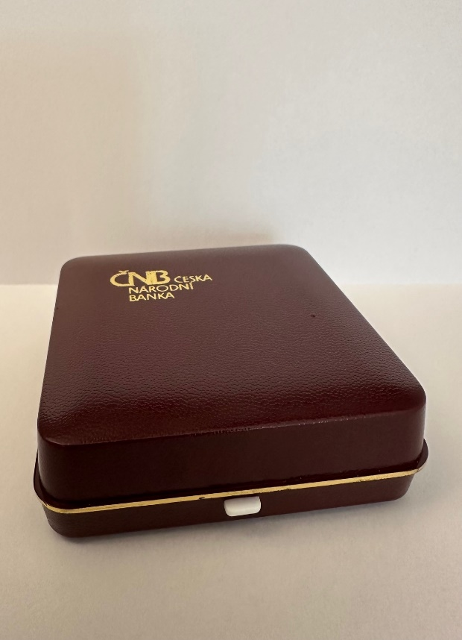 | 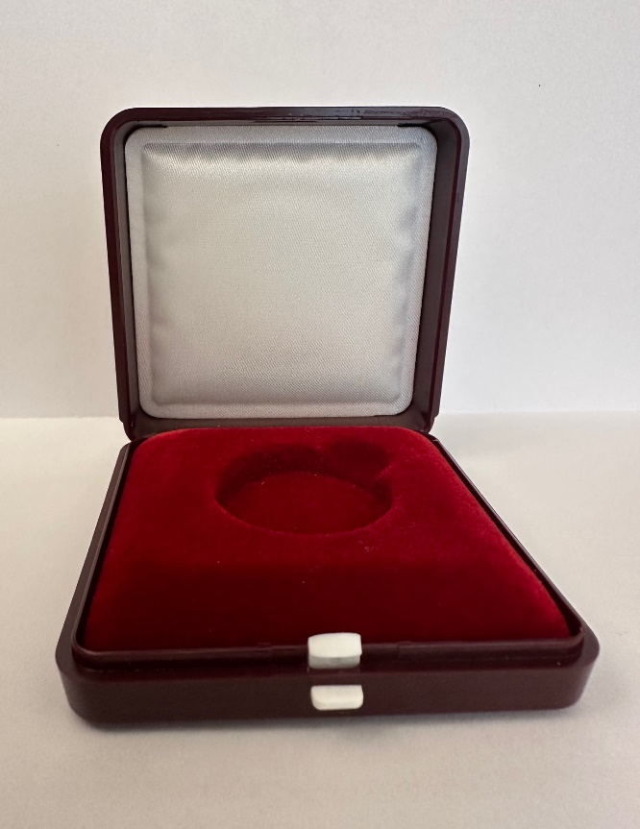

The CZK 100 and CZK 200 coins (silver coins) shall be delivered in transparent plastic capsules of a size appropriate to the diameter of the coin (29 mm for CZK 100; 31 mm for CZK 200). The CZK 200 coins in normal quality shall be delivered in capsules only.

The capsules with CZK 100 and CZK 200 coins in proof quality shall be placed in dark blue plastic cases. The shape of the case shall be square, with outer side dimensions in the range of 60 to 65 mm (Fig. 1).

The lining of the case for holding the capsule with the coin shall also be blue. The lining shall contain a shaped opening for the capsule with a side cutout for easy removal of the capsule with the coin from the lining without the need to turn the case upside down (Fig. 2). The inner side of the upper lid of the case shall be lined with white padding (Fig. 2).

All parts of the packaging must be manufactured precisely and neatly, free of burrs and other defects that typically arise during the processing of plastics. All parts of the packaging must be made of materials that do not damage wood, plastics, paper or paint and do not accelerate the oxidation of metals.

The capsule shall be made of clear plastic that is adequately resistant to scratching and cracking caused by normal handling or by the weight of the coin itself. The plastic case shall be made of plastic that is adequately resistant to mechanical and chemical effects when the case is used in a manner appropriate to the handling of numismatic material.

The specific shade of blue for the case and the lining shall be determined by the Buyer on the basis of a colour chart provided by the Supplier.

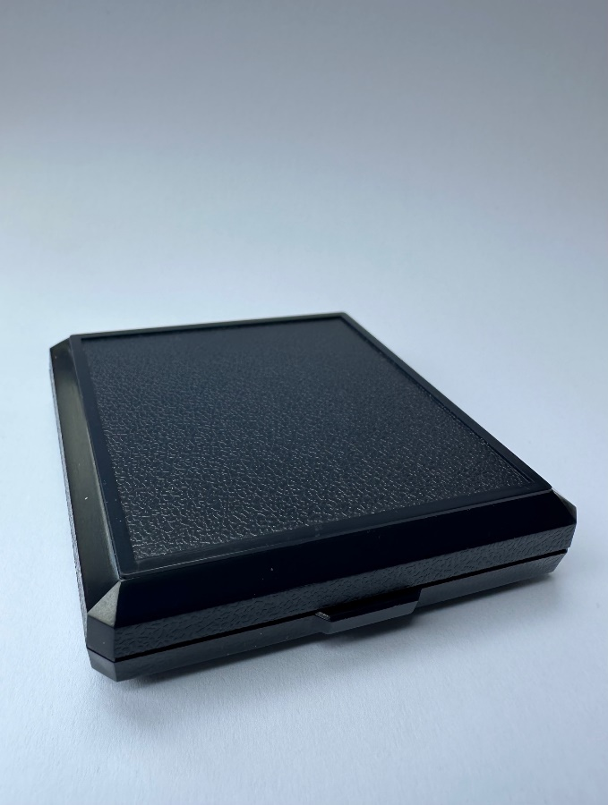 | 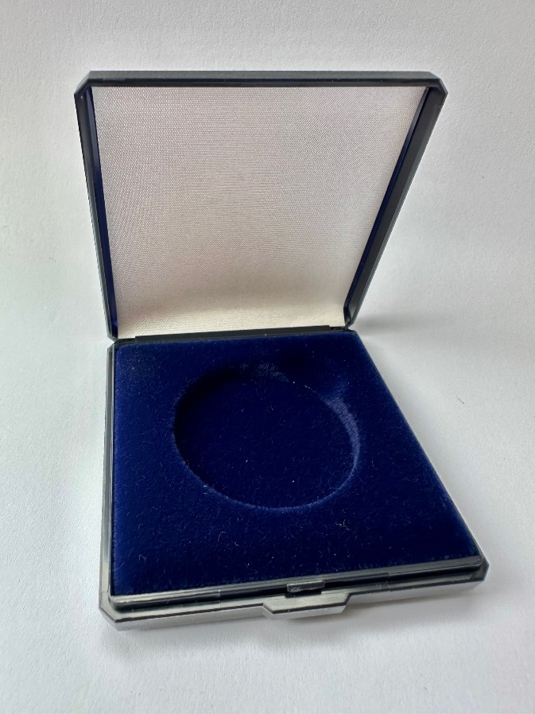

The CZK 500 coins (silver coins) shall be delivered in transparent plastic capsules of a size appropriate to the diameter of the coin (40 mm), placed in dark blue plastic cases. The surface of the case shall be matt and its shape square, with outer dimensions of 85 × 85 mm (Figs. 1 and 2).

Cases for coins in normal quality shall not bear the CNB logo on the outer lid and the decorative silver stripe on the upper lid (Fig. 1).

Cases for coins in proof quality shall bear on the outer lid a three-line CNB logo in silver, applied by embossing through foil or another suitable technique, and a silver decorative stripe shall run along the outer edge of the upper lid (Fig. 2).

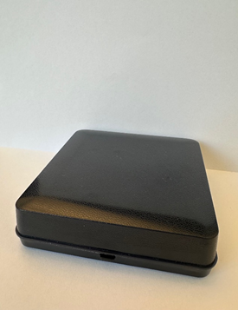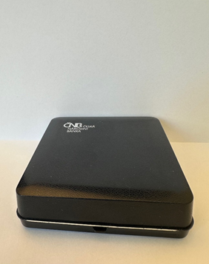
Fig. 1 Fig. 2

The lining of the cases for holding the capsule with the coin (both normal and proof quality) shall also be blue. The lining shall contain a shaped opening for the capsule with a side cutout for easy removal of the capsule with the coin from the lining without the need to turn the case upside down (Fig. 3). The inner side of the upper lid shall be lined with white padding (Fig. 4).

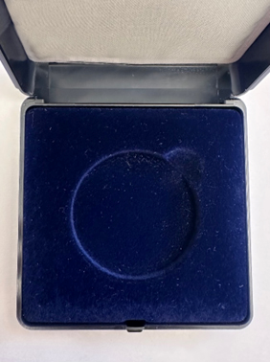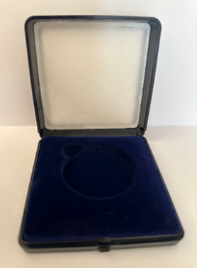
Fig. 3 Fig. 4

All parts of the packaging must be manufactured precisely and neatly, free of burrs and other defects that typically arise during the processing of plastics. All parts of the packaging must be made of materials that do not damage wood, plastics, paper or paint and do not accelerate the oxidation of metals.

The capsule shall be made of clear plastic that is adequately resistant to scratching and cracking caused by normal handling or by the weight of the coin itself. The plastic case shall be made of plastic that is adequately resistant to mechanical and chemical effects when the case is used in a manner appropriate to the handling of numismatic material.

The specific shade of blue for the case and the lining shall be determined by the Buyer on the basis of a colour chart provided by the Supplier.

The CZK 1,000 coins (silver coins) shall be delivered in transparent plastic capsules of a size appropriate to the diameter of the coin (50 mm), placed in “book-style” cardboard cases with a concealed magnetic closure, with outer dimensions of 95 × 95 mm and an internal insert of size 90 × 90 mm (Figs. 1 and 2). The height of the cardboard case shall be 40 mm. The case shall be made of cardboard covered with smooth matt paper in dark blue. The internal paper insert shall contain an opening for the capsule with a side cutout for easy removal of the capsule with the coin without the need to turn the case upside down. The inner lining of the paper insert shall be made of dark foam (Fig. 2).

On the outer side of the upper lid of the case there shall be a three-line CNB logo in silver, applied by embossing through foil or another suitable technique (Fig. 1).

All parts of the packaging must be manufactured precisely and neatly, free of burrs and other defects. All parts of the packaging must be made of materials that do not damage wood, plastics, paper or paint and do not accelerate the oxidation of metals.

The capsule shall be made of clear plastic that is adequately resistant to scratching and cracking caused by normal handling or by the weight of the coin itself.

The cardboard case shall be made of materials adequately resistant to mechanical and chemical effects when the case is used in a manner appropriate to the handling of numismatic material.

The specific shade of blue for the case and the lining shall be determined by the Buyer on the basis of a colour chart provided by the Supplier

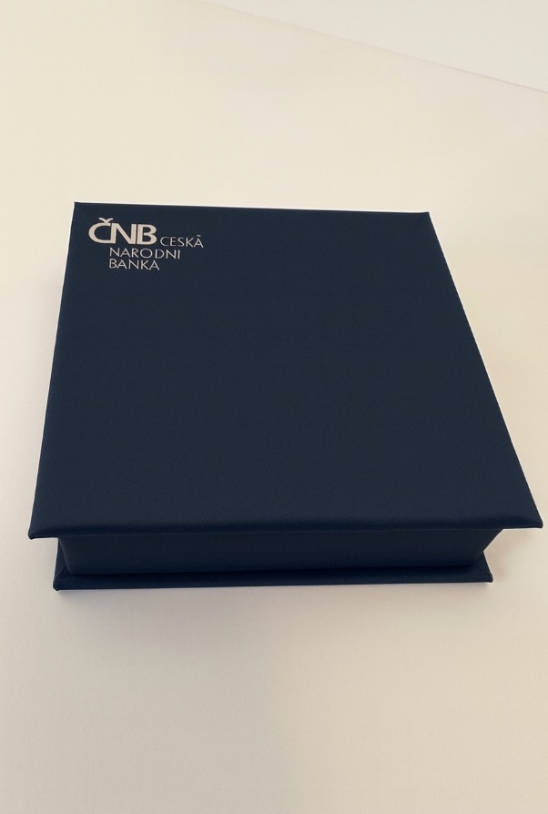 | 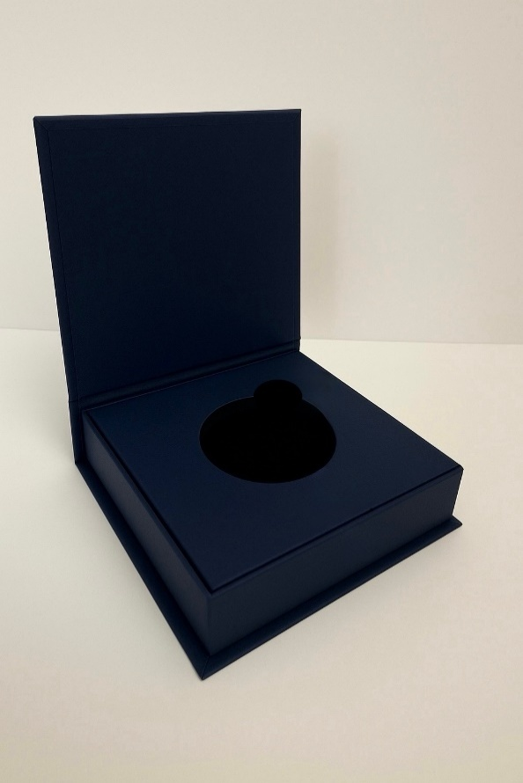
Fig. 1 | Fig. 2

The CZK 10,000 coins (silver coins) shall be delivered in wooden cases wrapped in a card outer sleeve. The shape of the case shall be square or rectangular, with dimensions appropriate to coins of 100 mm in diameter.

All parts of the packaging must be manufactured precisely and neatly, free of burrs and other defects that typically arise in the processing of plastics, wood and paper. All parts of the packaging, including stains, paints, varnishes and adhesives, must be made of materials that do not damage plastics, wood, paper or paint and do not accelerate the oxidation of metals, in particular silver.

The case shall be made of hardwood rated according to the six-class scale, i.e. with a load resistance of more than 650 kg/cm². The wood shall be stained and/or varnished; the specific shade of the stain and the colour of the varnish shall be determined by the Buyer on the basis of a colour chart provided by the Supplier (light-coloured wood is used in the illustrative images). The outer side of the lid of the case shall be left without any application (Fig.1).

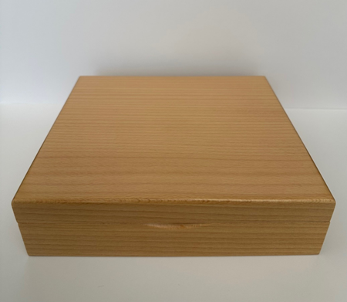
Fig. 1

The outer sleeve shall be made of white cardboard with a basis weight (grammage) of at least 250 gsm and a coated outer surface or coated outer and inner surfaces (Fig. 2). A three-line CNB logo in black will be printed in the upper left corner (Fig. 3). The Buyer shall provide the Supplier with the logos in digital formats and precise colour specifications without undue delay after the contract is concluded.
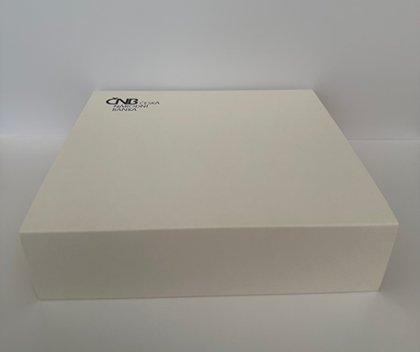
Fig. 2



Fig. 3

The hinges of the lid shall be metal, either visible or hidden.

The soft lining of the case for holding the coin shall be dark blue, matching the lining used for the CZK 200 and CZK 500 commemorative silver coins issued by the Buyer in 2016–2020 (a sample will be provided by the Buyer upon request). The lining shall contain a cutout for easy removal of the coin without the need to turn the case upside down (Fig. 4).

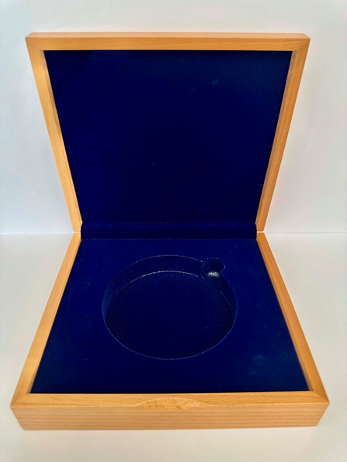
Fig. 4

A thin felt or other suitable material in a colour matching the stained and/or varnished wood shall be applied to the underside of the case to prevent the underside from being scratched (Fig. 5).

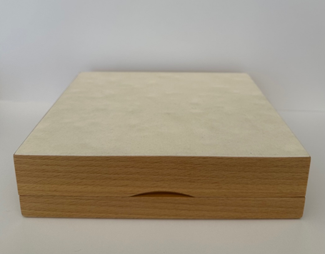
Fig. 5

The final design of the cases and the outer sleeve shall be subject to the Buyer’s approval.

Annex 5

Catalogue of Defects

FOREIGN BODIES
These are small, and occasionally larger, foreign bodies, in particular hairs/fibres, larger dust particles, shavings of the same minting metal or of another material, and grease, which were present on the surface of the blank or the die, or became lodged between the blank and the die before minting. The foreign body either remains pressed into the surface or falls away, leaving a negative imprint on the surface.
BURRS
These are usually very thin and sharp protrusions of the minting metal extending from the interface between the raised rim (“frame”) and the edge of the coin. They are often further deformed during subsequent handling (e.g. when closing the capsule).
STAINS AND SMUDGES
These may have various origins (impurities in the metal, contamination of the surface of the blanks before minting or of the coins after minting) and various colours (whitish, rusty, dark), sizes, shapes and appearances. They are a very common surface defect on coins.
MATTING DEFECTS
These defects appear as shiny patches in areas that are intended to be matt. They may occur on lightly matt areas of coins in normal (standard) quality, but more frequently appear on heavily matt areas of coins in proof quality.
SCRATCHES AND PITS
These defects (scratches, grooves, dents, etc.) appear as negative (indented) marks on the surface of the coin. They are of mechanical origin, caused by contact between the coin and hard objects, typically when the coin falls onto an object or an object falls onto the coin.
DEFORMATION OF THE RAISED RIM AND FILLET
This refers to a narrowing of the raised rim and an associated deformation of the fillet (the curved transition between the rim and the coin field).
MOIRÉ
This appears as an uneven matt sheen, reminiscent of moiré patterns on textiles.
NON-HOMOGENEOUS MATERIAL
The minting metal should be homogeneous, i.e. have the same composition at all points. Non-homogeneity, which is relatively common in base metals, is rare in high-purity precious-metal coins. If the differing presence of constituent elements is visible, it manifests as differing colour; in other cases, it may not be visually detectable.
FINGERPRINTS
Dermatoglyphic traces on the surface of coins.
PACKAGING DEFECTS
These are various defects in the packaging (capsules and cases), e.g. non-homogeneous material, cracked packaging, scratched packaging, defective case lining and colour instability.

OTHER DEFECTS
Defects not specified above.

Notice:
The above defects are assessed primarily with the naked eye, without the use of technical instruments, which may subsequently be used to confirm the defect and the justification of the complaint.

